1/ Download MySQL Installer via: https://dev.mysql.com/downloads/installer/

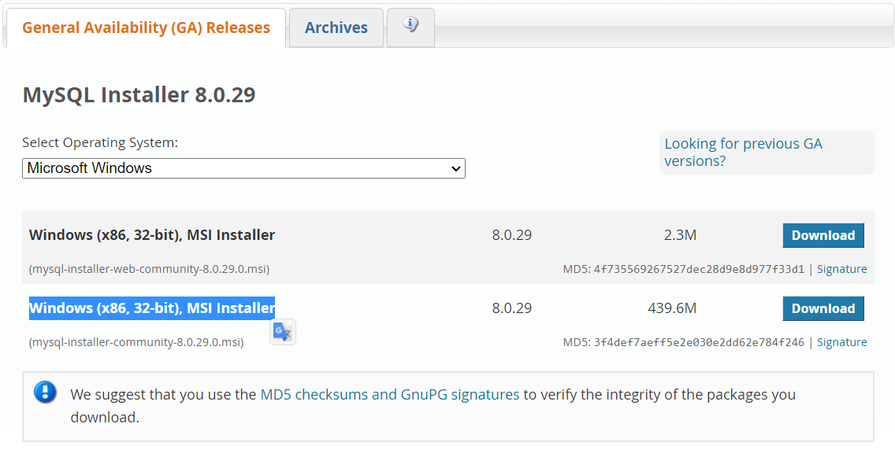

2/ Download MySQL workbench via: https://dev.mysql.com/downloads/workbench/

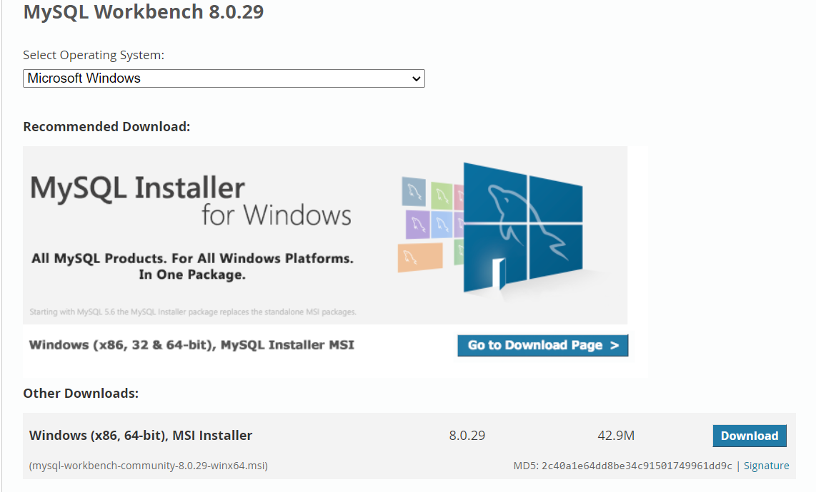

3/ Install MySQL installer and My SQL workbench

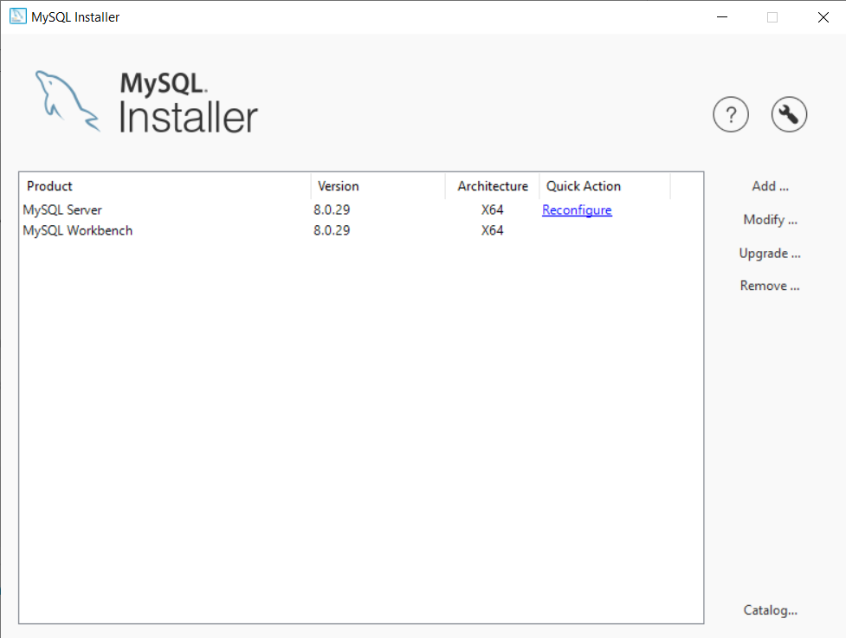

(Screenshot after open and install the installer)

3A/ Setup server through MySQL installer

Add

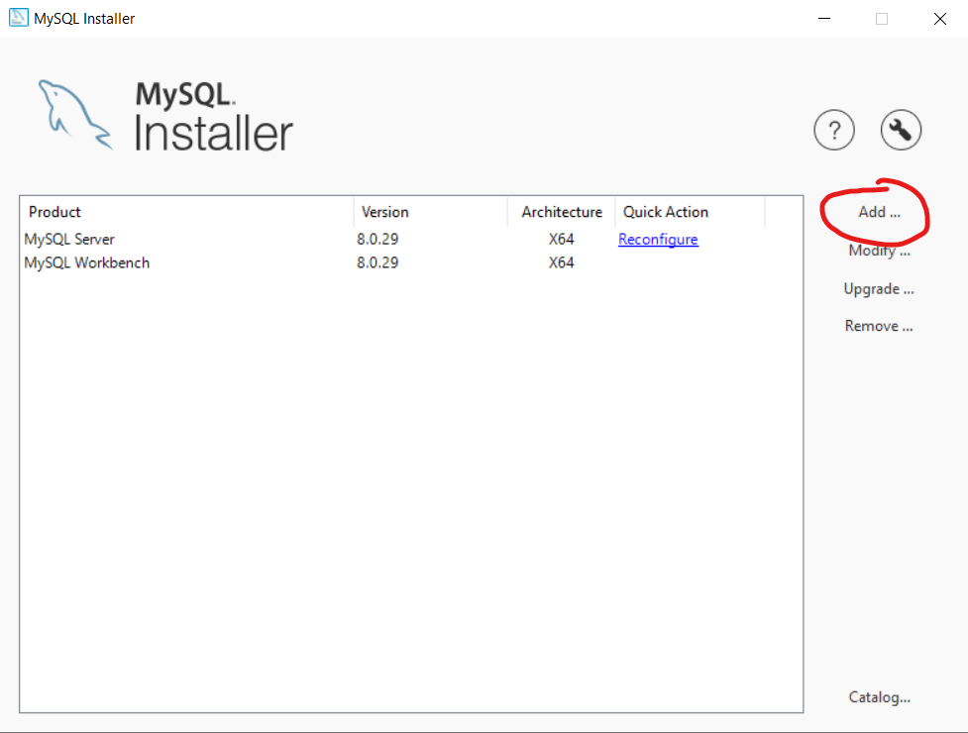

3B/ Choose the following

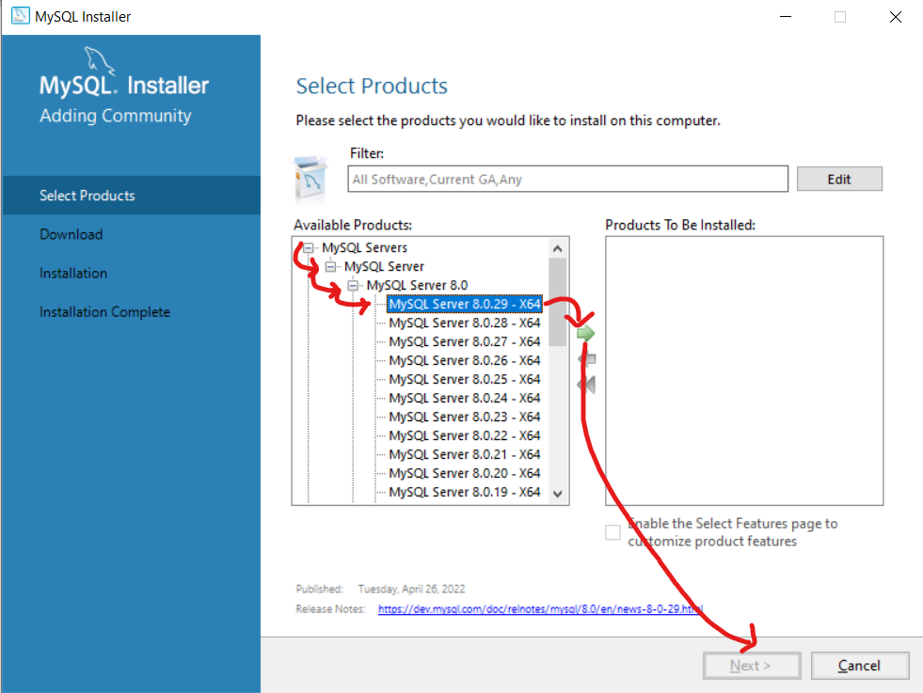

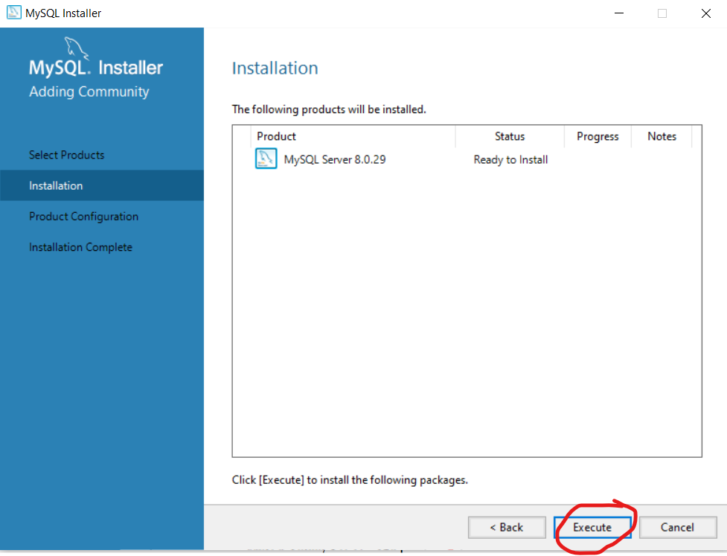

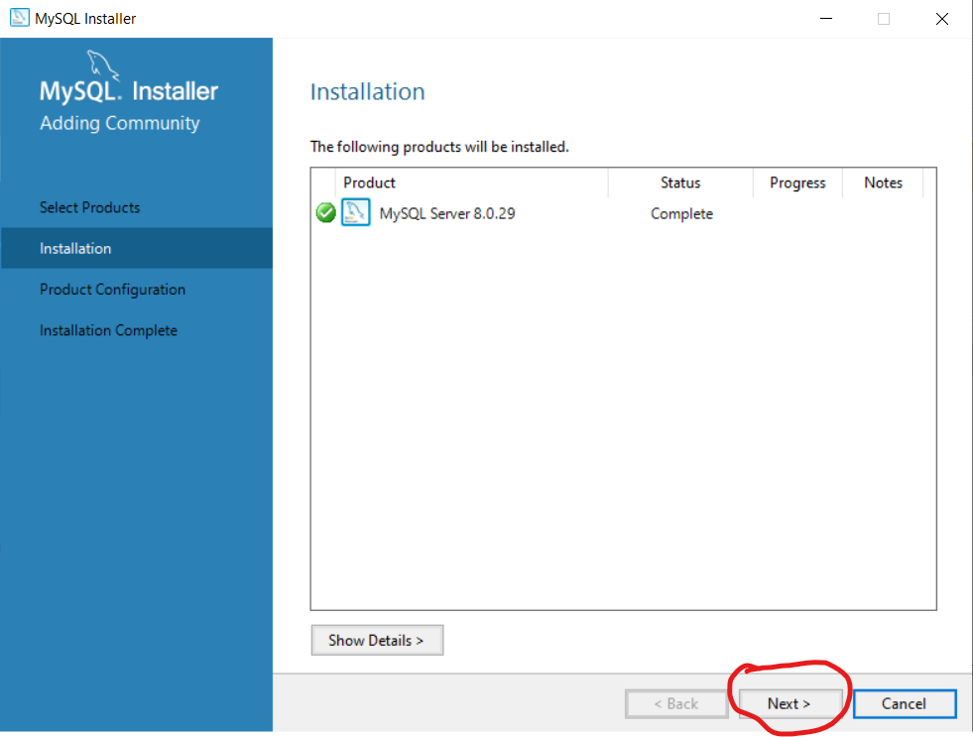

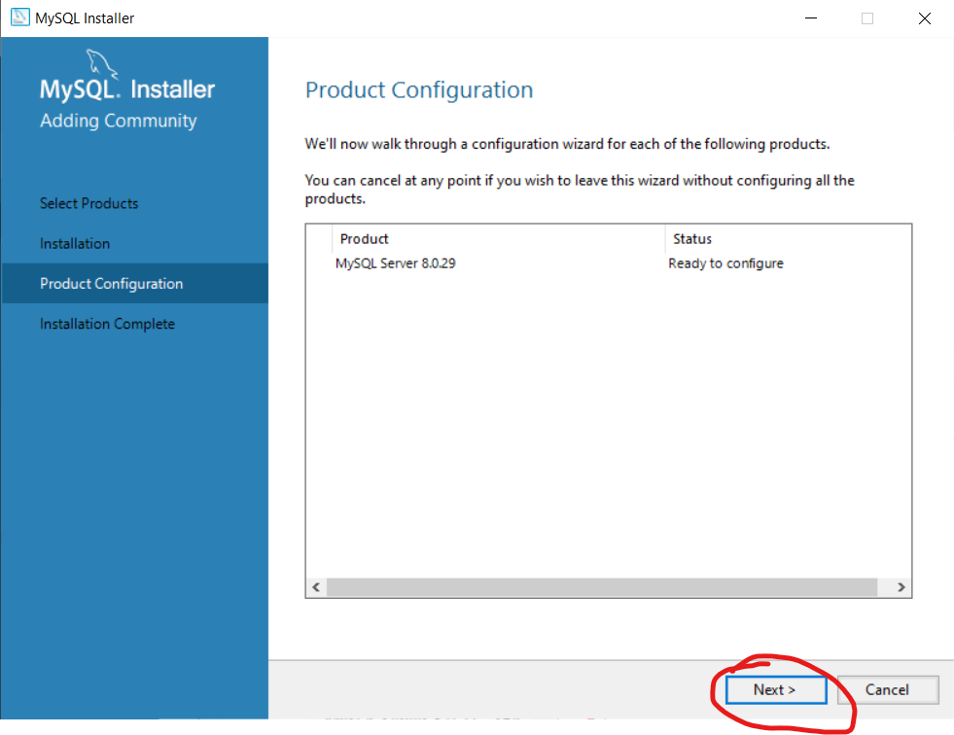

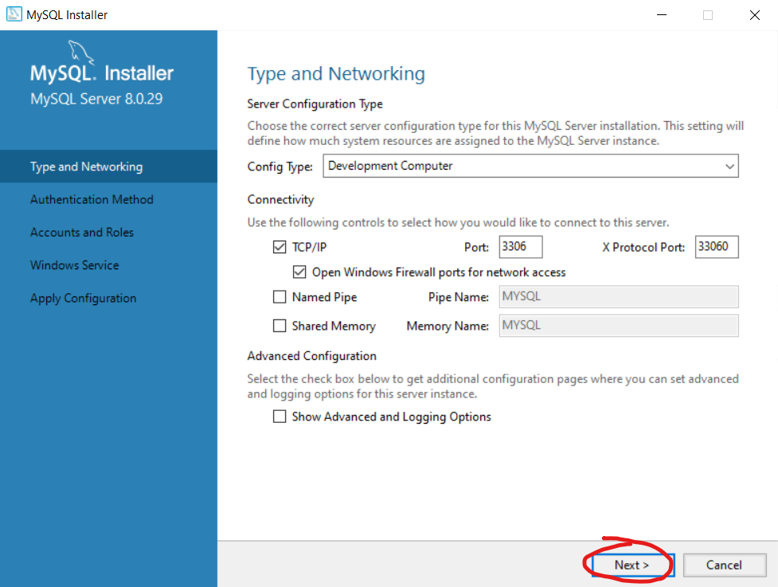

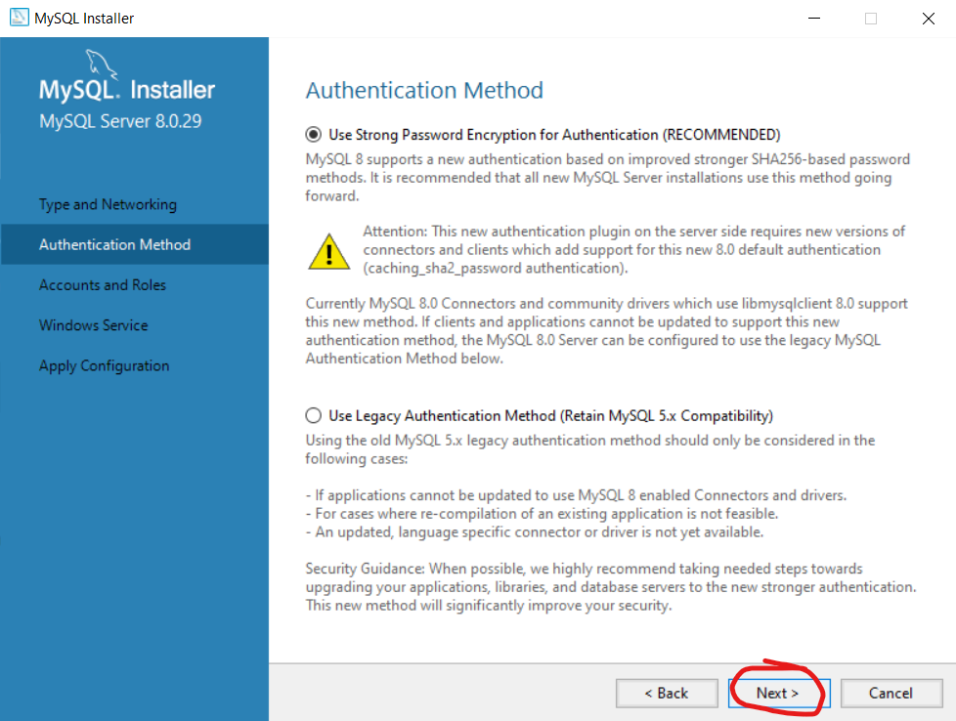

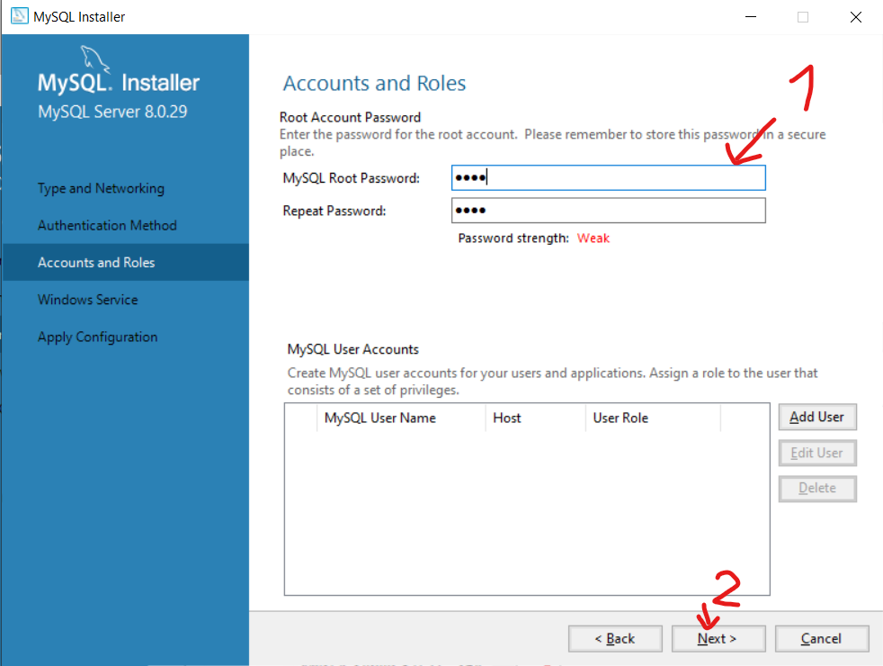

(1)Type in password and REMEMBER it

(2)Next

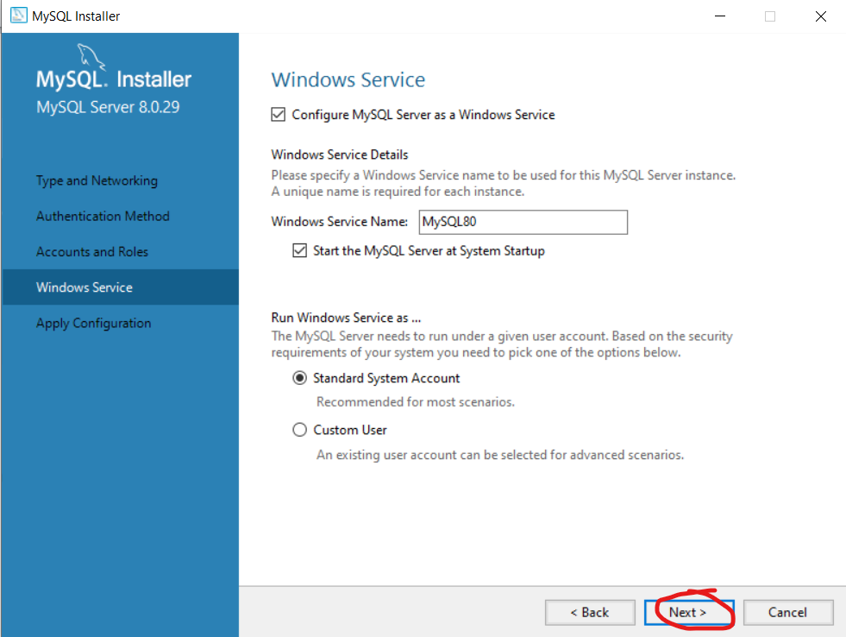

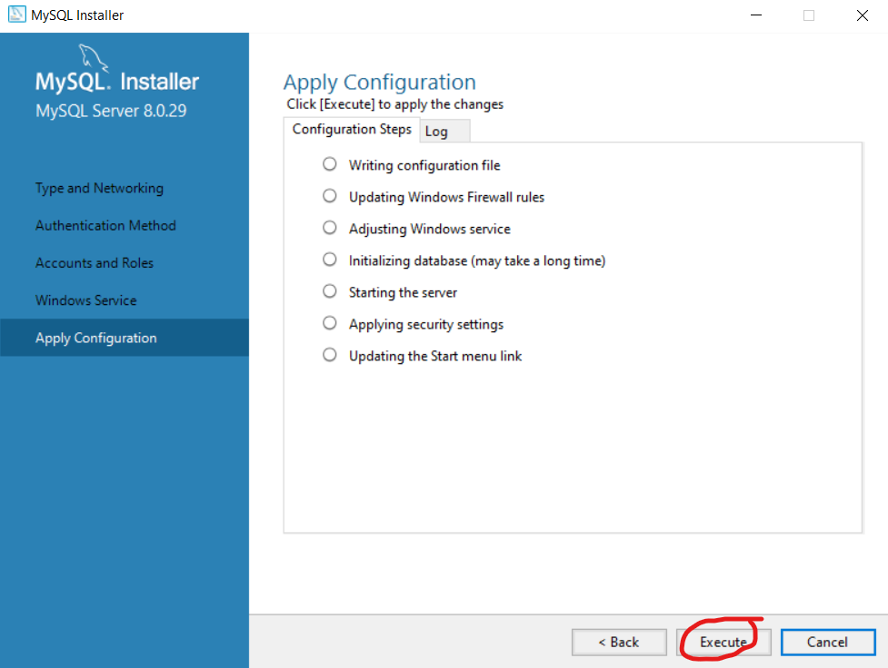

Execute, wait and finish

Successfully created a server

3B/ My SQL workbench is a pretty standard linear installer so just open the installer and install

4/ Open MySQL workbench

Do the following 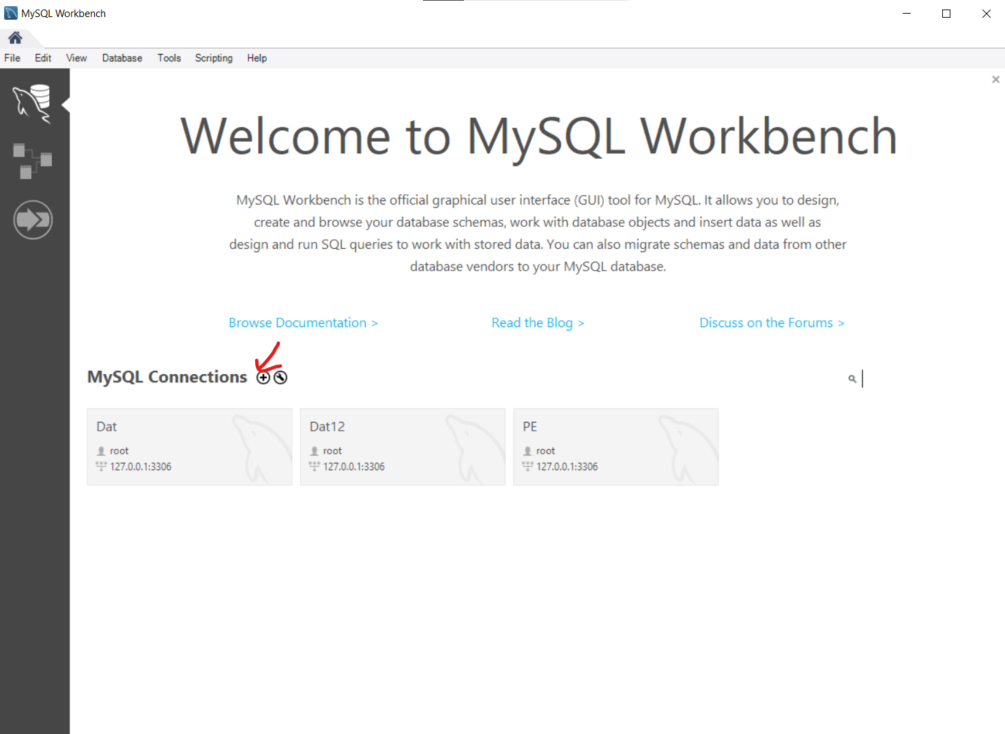

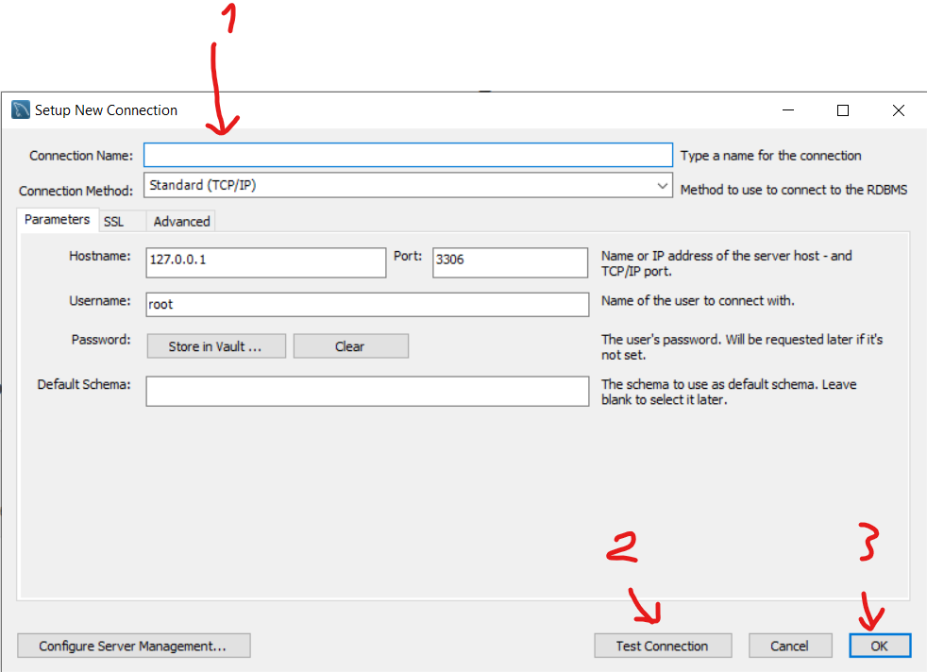

1. Type in the name (whatever don’t care)
2. Test the connection
3. Ok for finish

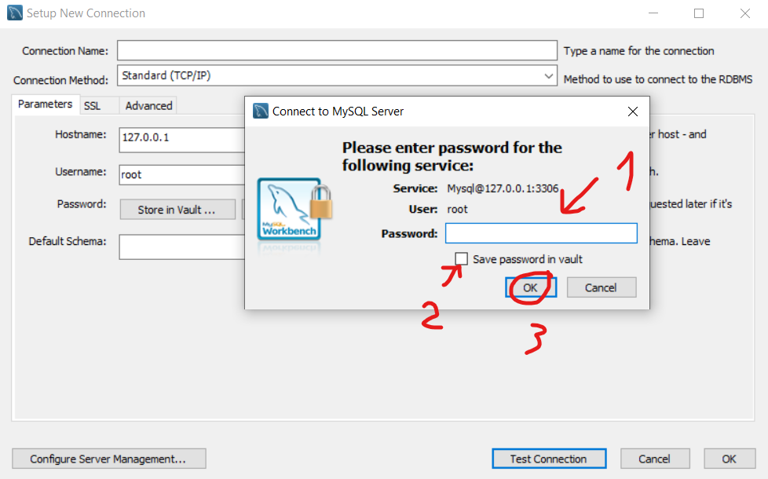

1. Type in THE password
2. Tick if too lazy to remember password
3. Done

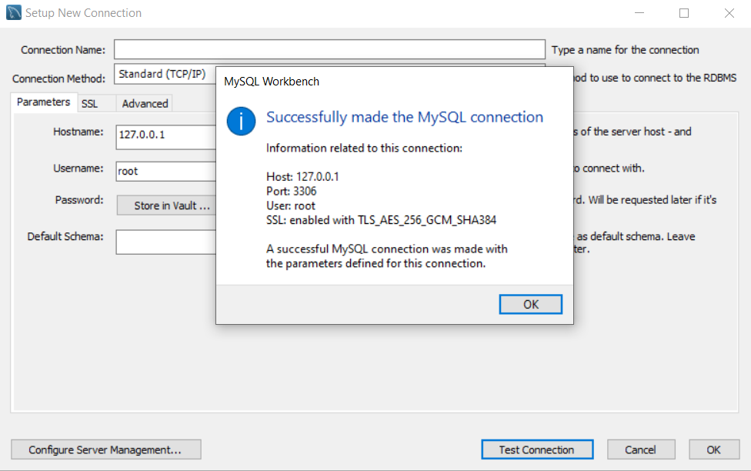

***Forward Engineer to Local Host***

Open Database Pharmacy Table relation.mwb

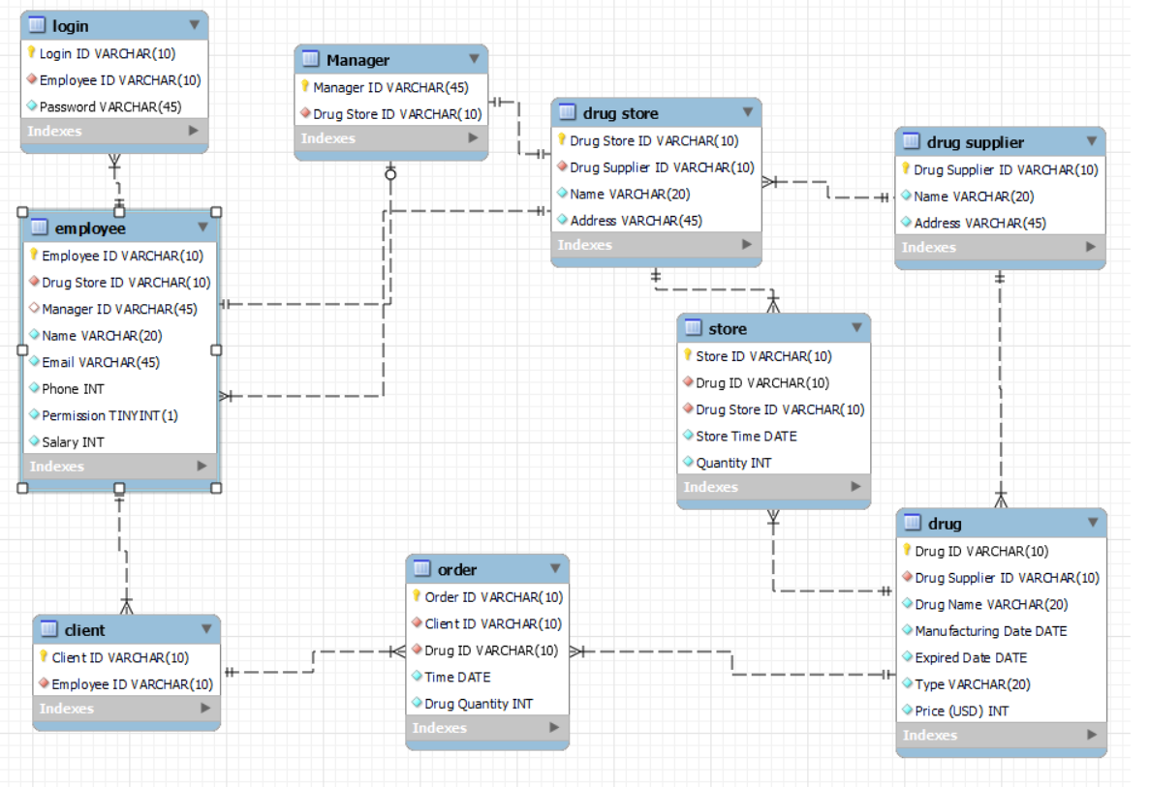

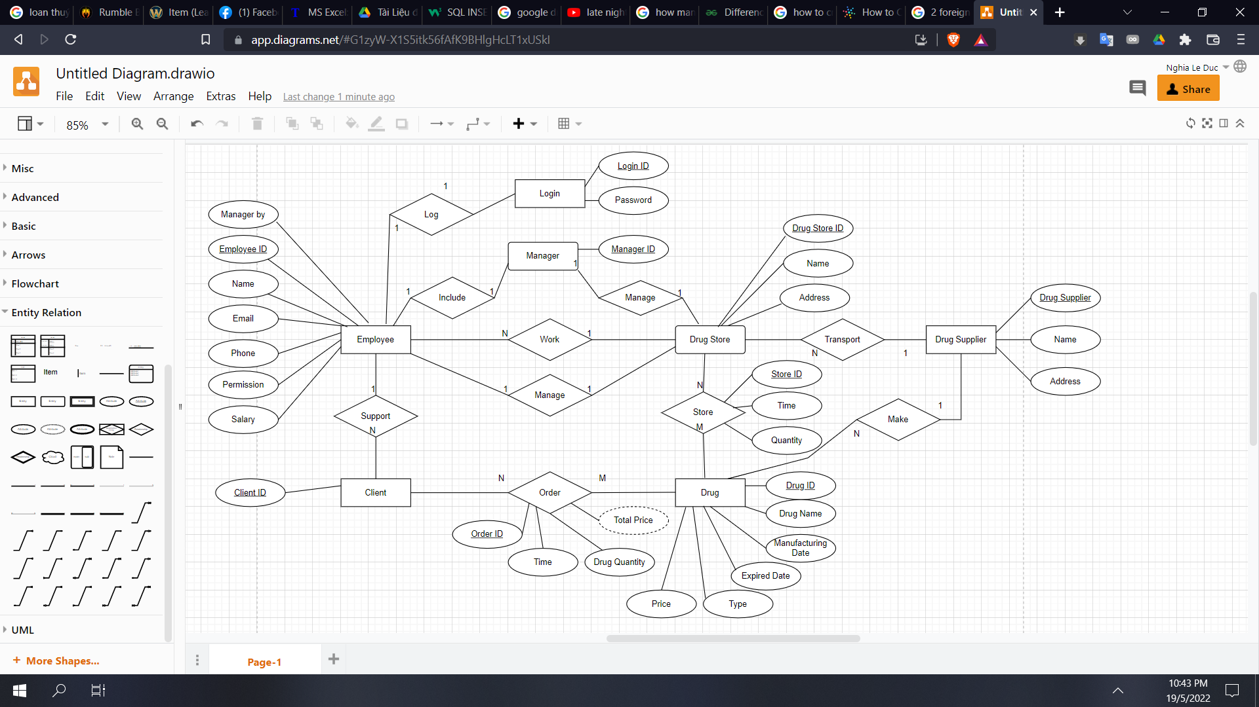

ER diagram

select database/forward engineer, next all until finish and closed

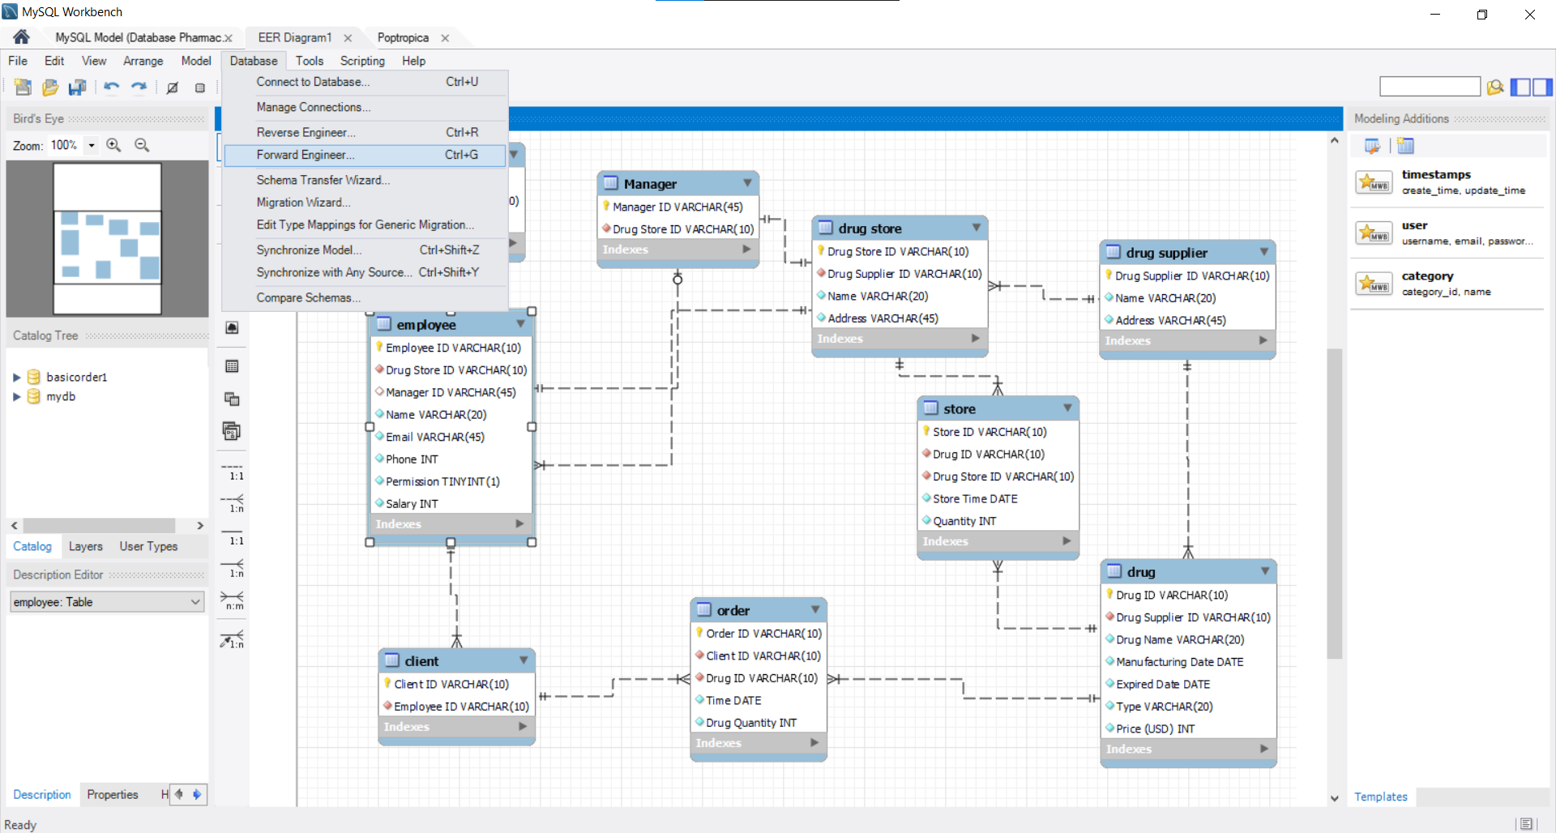

Press next until finished

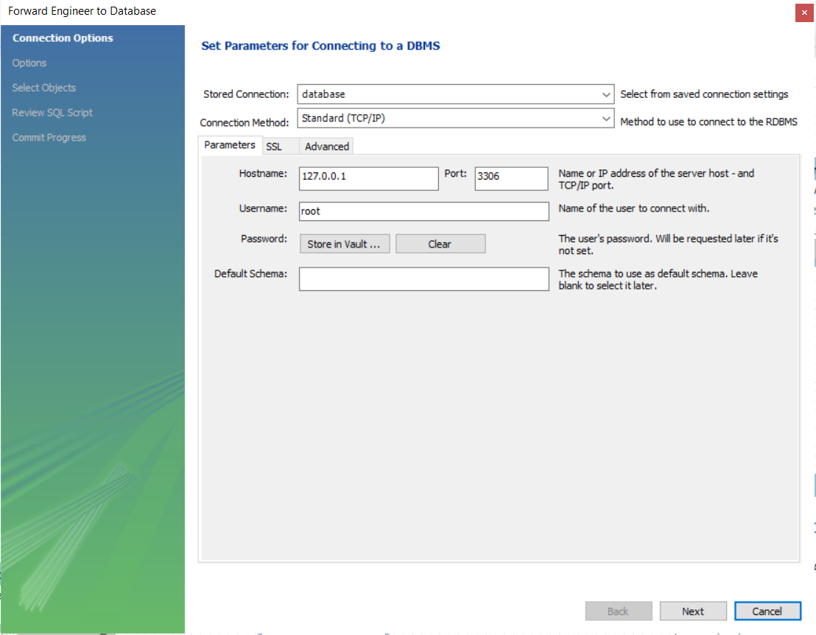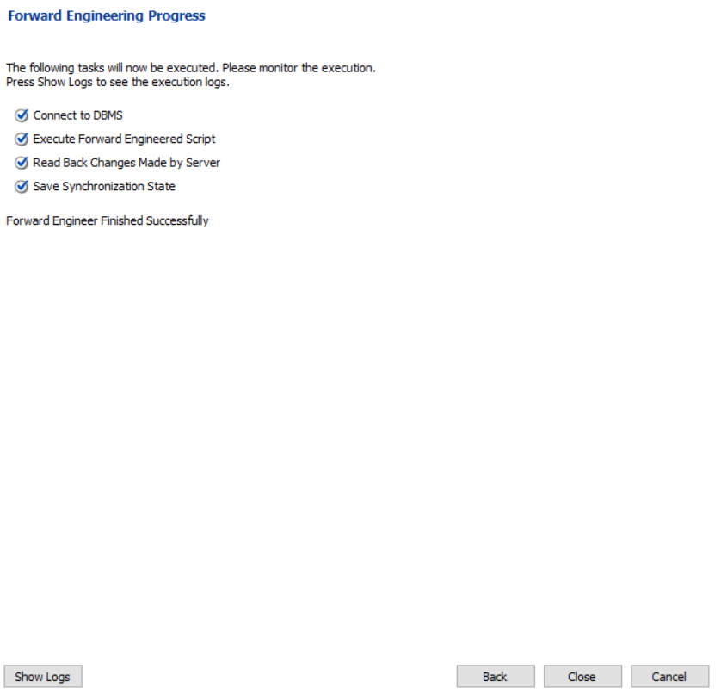

Then closed

*Go to the local host name, if you meet the 1 interface, just click the schemas and it will turn to the second interface,then press the button in the red circle in second interface*

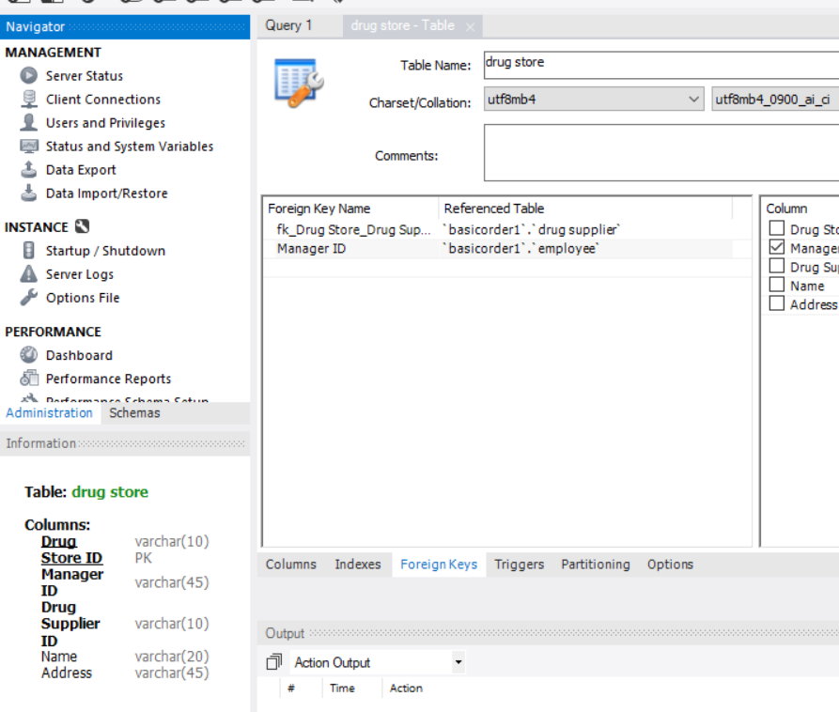*Then the basicorder1 is appear.*

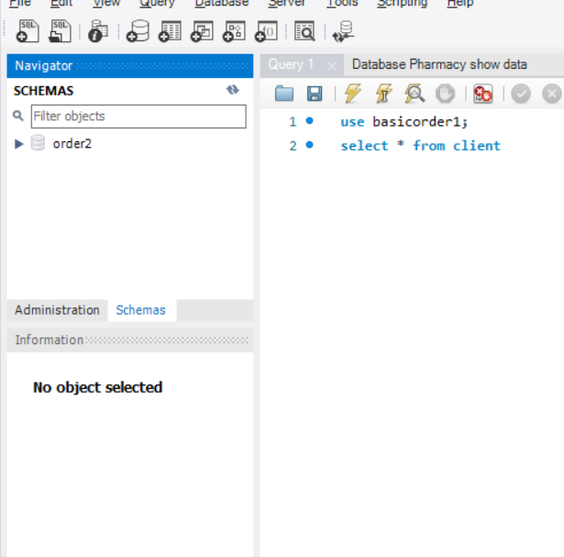

2

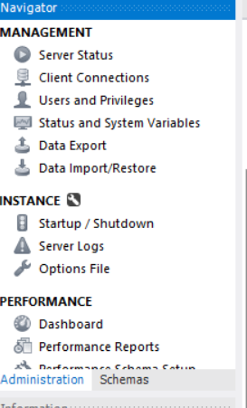

1

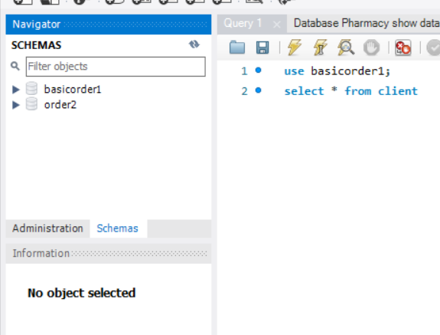

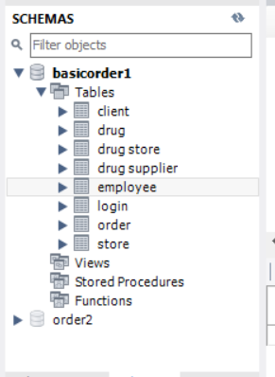

Open the basicorder1 schema, tables

***Insert Data***

***Copy the data and insert into the query as the image below show***

**// Copy all of this**

use basicorder1;

insert into `DrugSupplier`

values ('S1','Europe','Europe' );

insert into `Drug`

values('D1', 'S1', 'Panadol', '2019-02-02', '2019-02-12', 'bar', 10 ),

('D2', 'S1', 'Vitamin C', '2019-02-03', '2019-03-12', 'bar', 20 ),

('D3', 'S1', 'Stomach', '2019-05-05', '2020-05-03', 'bar', 50 );

insert into `DrugStore`

values('DS1', 'S1', 'Earth','VGU' ),

('DS2', 'S1', 'Moon', 'VGU' );

insert into `Store`

values('St1', 'D1', 'DS1', '2020-06-07', 30 ),

('St2', 'D2', 'DS1', '2020-06-07', 80 ),

('St3', 'D3', 'DS1', '2020-06-07', 35 ),

('St4', 'D1', 'DS2', '2020-06-07', 15 ),

('St5', 'D2', 'DS2', '2020-06-07', 50 ),

('St6', 'D3', 'DS2', '2020-06-07', 25 );

insert into `Manager`

values('M1','DS1'),

('M2','DS2');

insert into `Employee`

values('E1', 'DS1', Null, 'cat1', 'cat1gmail.com', 201, 0, 500 ),

('E2', 'DS1', Null, 'cat2', 'cat2gmail.com', 202, 0, 500 ),

('E3', 'DS2', Null, 'cat3', 'cat3gmail.com', 203, 0, 500 ),

('E4', 'DS1', 'M1', 'cat4', 'cat4gmail.com', 204, 1, 2000 ),

('E5', 'DS2', 'M2', 'cat5', 'cat5gmail.com', 205, 1, 2000 );

insert into `Login`

values( 'L1', 'E1', 'PS1' ),

( 'L2', 'E2', 'PS2' ),

( 'L3', 'E3', 'PS3' ),

( 'L4', 'E4', 'PS4' ),

( 'L5', 'E5', 'PS5' );

insert into `Client`

values( 'C1', 'E1' ),

( 'C2', 'E3' ),

( 'C3', 'E2' ),

( 'C4', 'E2' ),

( 'C5', 'E1' );

insert into `Order`

values( 'O1', 'C1', 'D1', '2019-10-10', 38 ),

( 'O2', 'C1', 'D2', '2019-10-10', 38 ),

( 'O3', 'C1', 'D3', '2019-10-10', 25 ),

( 'O4', 'C2', 'D1', '2019-10-10', 30 ),

( 'O5', 'C2', 'D2', '2019-10-10', 36 ),

( 'O6', 'C2', 'D3', '2019-10-10', 30 ),

( 'O7', 'C3', 'D1', '2019-10-10', 29 ),

( 'O8', 'C3', 'D2', '2019-10-10', 28 ),

( 'O9', 'C3', 'D3', '2019-10-10', 25 ),

( 'O10', 'C4', 'D1', '2019-10-10', 22 ),

( 'O11', 'C4', 'D2', '2019-10-10', 39 ),

( 'O12', 'C4', 'D3', '2019-10-10', 33 ),

( 'O13', 'C5', 'D1', '2019-10-10', 21 ),

( 'O14', 'C5', 'D2', '2019-10-10', 30 ),

( 'O15', 'C5', 'D3', '2019-10-10', 22 );

**// End of the copy**

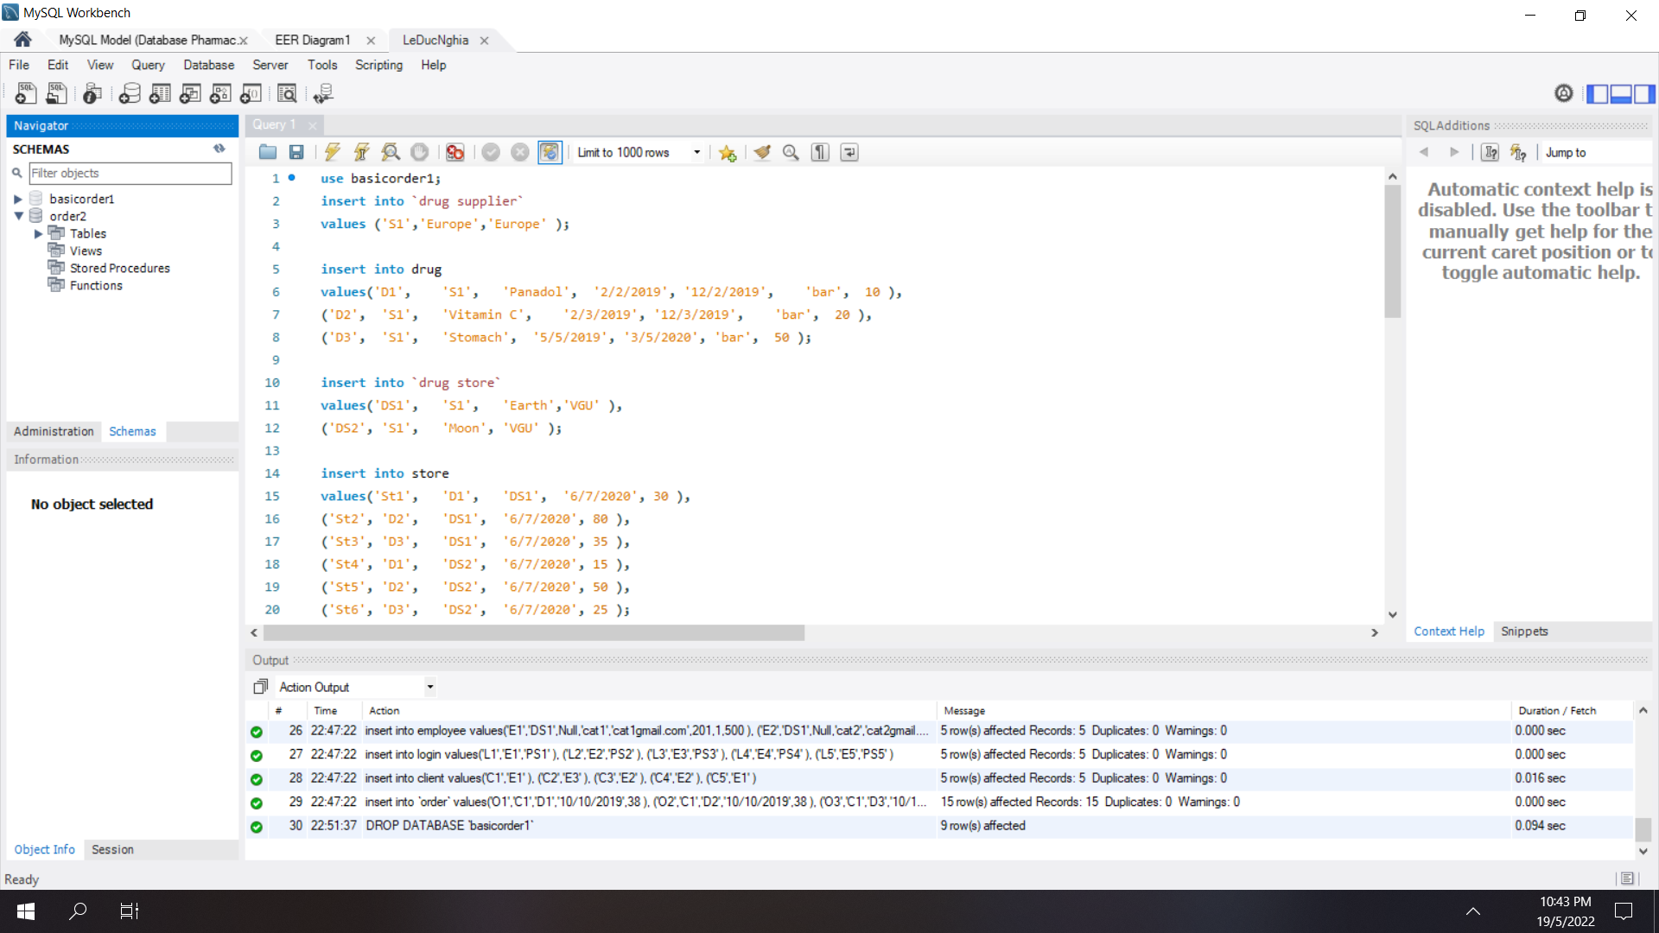

Select lightning

Show this mean you are done

***Check data***

***// Show the attributes type in each table***

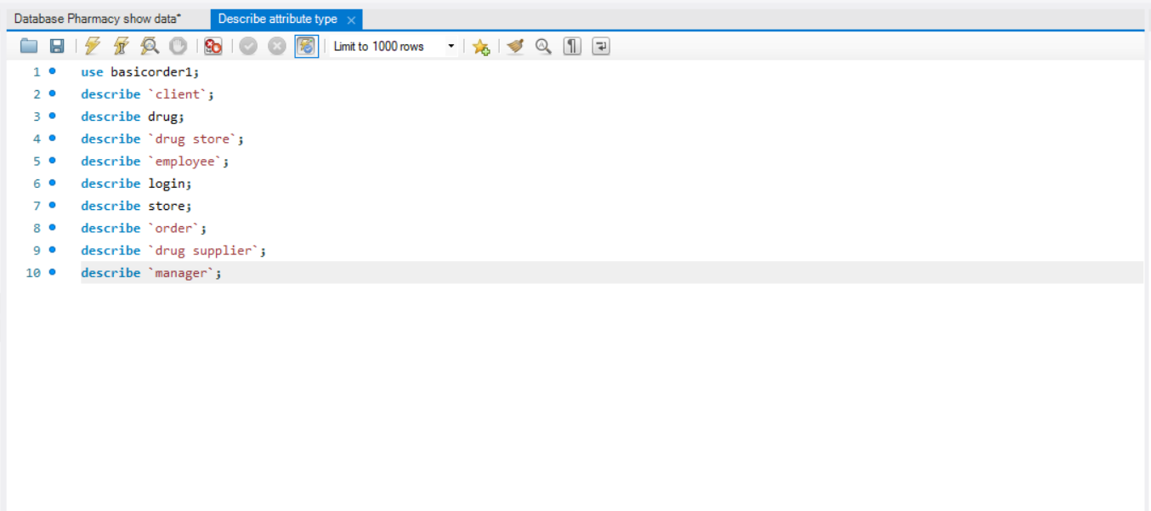

use basicorder1;

describe `Client`;

describe `Drug`;

describe `DrugStore`;

describe `Employee`;

describe `Login`;

describe `Store`;

describe `Order`;

describe `DrugSupplier`;

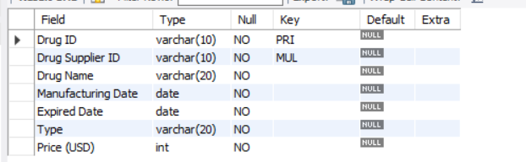

Drug table

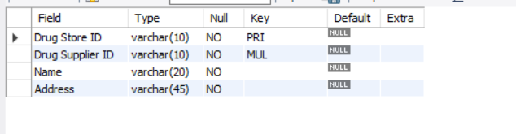

Drug Store table

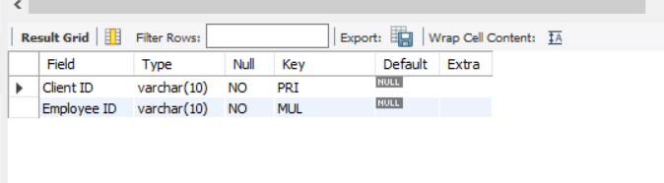

Client table

Employee table

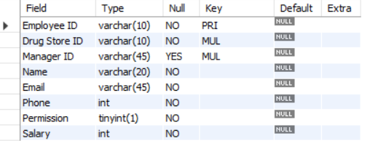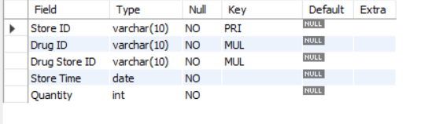

Store ID table

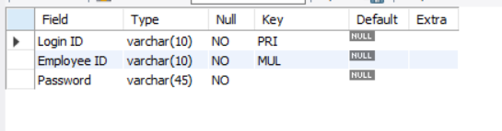

Login table

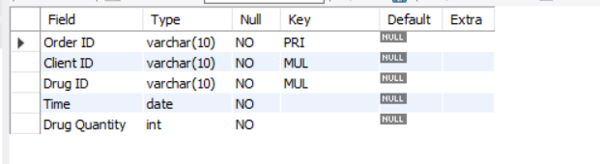

Order table

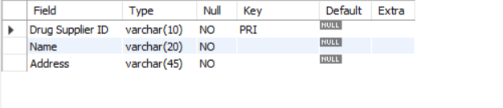

Drug Supplier table

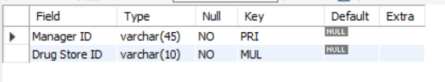

Manager table

***// Show the Data***

//Copy all this text

use basicorder1;

select * from `Client`;

select * from `Drug`;

select * from `DrugStore`;

select * from `Employee`;

select * from `Login`;

select * from `Store`;

select * from `Order`;

select * from `DrugSupplier`;

select * from `Manager`;

***Pass to query 1 and press the lightning button***

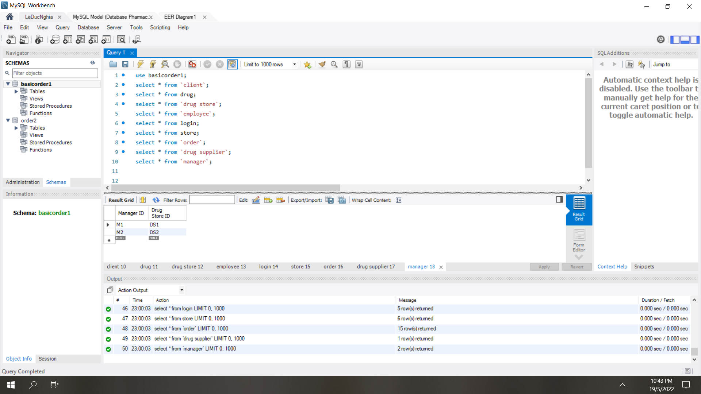

***Result***

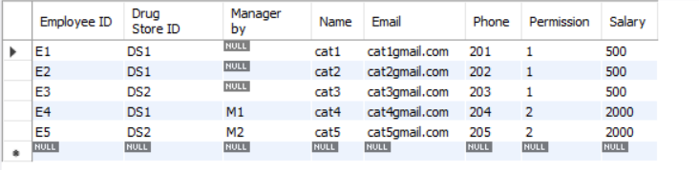

Employee table

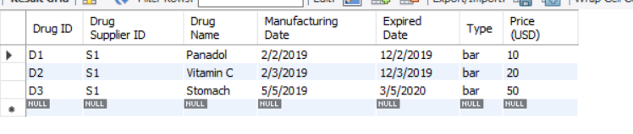

Drug table

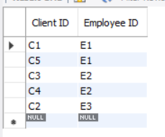

Client table

Drug Store table

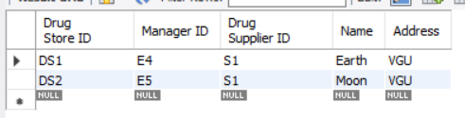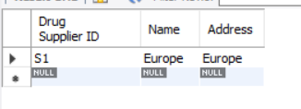

Drug Supplier table

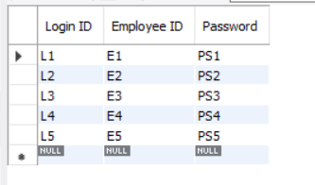

Login table

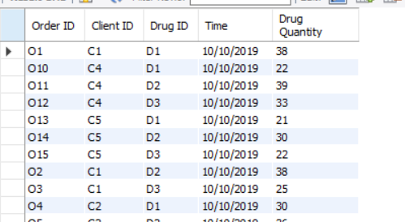

Order table

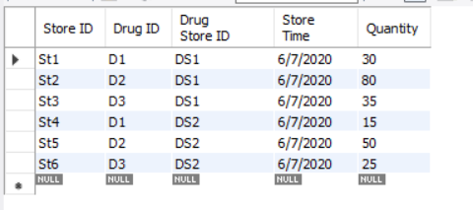

Store table

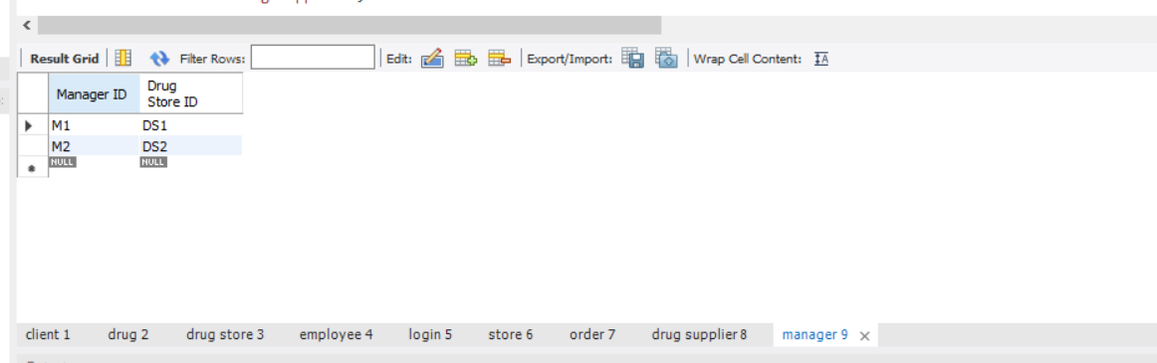

Manager table